INGLÊS

1) Label the following parts of the computer. Use the words from the box. Some words will not be used:

TACKLE – KEYBOARD – SOFTWARE – SCREEN – PRESS – MOUSE – WEBCAM – PRINTER - TELL

5

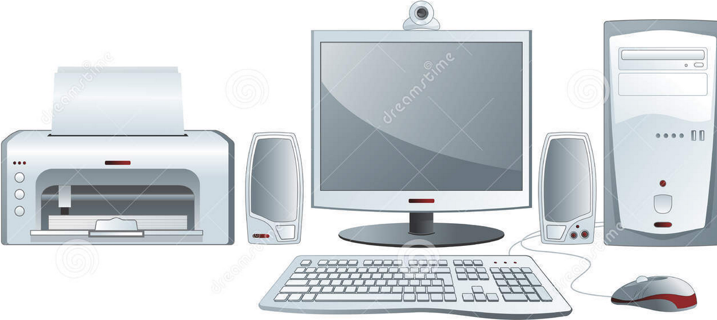
1
2
3
4

1) ________________________________________  2) ________________________________________  3) ________________________________________ | 4) _______________________________________  5) _______________________________________

2) Correlacione.
a) Paste  b) Drag  c) Scroll up  d) Attach  e) Print  f) Crop  g) Send | 1. ( ) Anexar  2. ( ) Mover a barra de rolamento para cima  3. ( ) Enviar  4. ( ) Arrastar um objeto com o cursor  5. ( ) Colar parte de um texto em outro lugar  6. ( ) Imprimir  7. ( ) Recortar parte de uma figura ou foto

3) Escreva o significado dos termos destacados no texto a seguir:

5  10 | Step 2 Configuration by Assistant on a PC  1.Power on the PC. Make sure your computer is connected to the Internet for the first time you use.  2.Switch on the transmitter first, and then power on the autopilot system. Connect the autopilot system to the PC with a Micro-USB cable. DO NOT break the connection until setup is finished.  3.Run the Assistant Software.  4.Observe the indicators on the left bottom of the software. (They are the connection indicator and communication indicator in order.) If the communication indicator is blinking, that the software is ready, please go to next step.  5.Select the “Info” option. Check the software firmware version. If the upgrade is available, you may update  the assistant software.  6.Select the “Upgrade” option. Check the Main Controller, GPS and IMU firmware version. (…)
http://dl.djicdn.com/downloads/nazam-v2/en/NAZA-M_Quick_Start_Guide_v1.26_en.pdf

a) Power on: __________________________  b) Computer: __________________________  c) Cable: _____________________________  d) Run: _______________________________ | e) Left: _________________________  f) Step: _________________________  g) Upgrade: ______________________  h) Controller: ______________________

